ETL process explanation with key screenshots

Data cleaning
We started the ETL process by first getting familiar with our dataset to truly understand what the dataset contained and how it was structured. There was some information provided in the Kaggle description, but there were still fields that were not explained and did not fit the explained/standard pattern.
...
Some of the problems we identified that needed “cleaning” were:
Missing Values
Many transactions had missing Description and Customer ID fields.
Products without descriptions were excluded from the dimension table, as descriptions are essential for business users to understand product performance

NULL CustomerID values were mapped to CustomerID = 0 with name "Anonymous”

This was solved using:
...

Invalid Data Entries
Negative Quantity, missing Description, lacking CustomerID
This was solved using:
...

Non-Product Categories
The source data contained something that must have been administrative codes, test entries, and non-product items that should not be analyzed as regular products.
Solution: After analyzing all the «StockCode» values manually, we came to the conclusion that these should be excluded. This because descriptions are essential for business owners to understand product performance.
NULL CustomerID values were mapped to CustomerID = 0 with name "Anonymous", representing approximately 30% of transactions (guest purchases)

This filtering removed around five thousand invalid rows, leaving only legitimate product transactions.

Shipping-related products were flagged with is_shipping = TRUE to enable accurate revenue analysis by separating shipping costs from product sales.

Shipping Cost Separation
Shipping costs were mixed with product sales, making revenue analysis inaccurate.

We created a flag (is_shipping) to identify shipping-related products. This allows us to filter out shipping costs when analyzing pure product revenue and performance statistics
Data Standardization
Product descriptions were cleaned using:
Trim operations to remove leading/trailing whitespace
Title case formatting for consistency
Business Logic Separation
Cancellations (negative quantities) were separated from sales (positive quantities) into two distinct fact tables (factsales and factcancellations). This maintains clear business process separation and improves query performance.
Impact: These data quality measures resulted in clean, validated data in the warehouse. All analyses and dashboards now work with business-relevant data only.

ETL ?

- Database set up – Before the ETL process can begin we need to create the data warehouse structure in Postgres. Creating schema and tables.

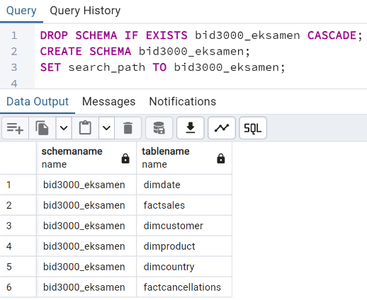

- Database set up – Before the ETL process can begin we need to create the data warehouse structure in Postgres. Creating schema and tables.

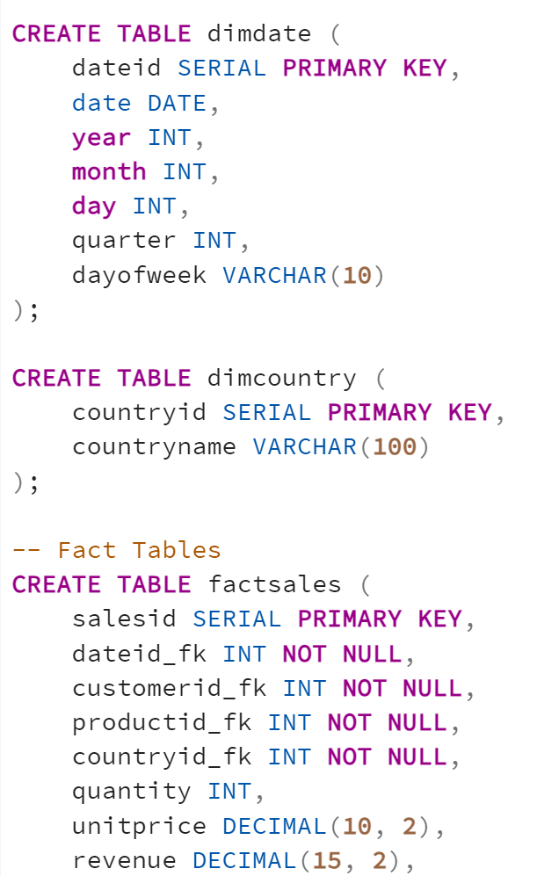

- Database connection: Once the schema is created, the Python ETL script connects to the database with this code:
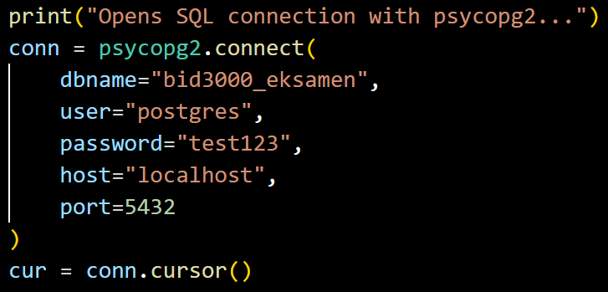

- Extract data from CSV (file df = pd.read_csv('online_retail_II.csv')
Data Source Structure:
InvoiceNo: Transaction identifier
StockCode: Product identifier
Description: Product description
Quantity: Units purchased (negative = cancellation)
InvoiceDate: Transaction timestamp
Price: Unit price
CustomerID: Customer identifier (can be null) -
Country: Customer country
Screenshot: The CSV file contains over 1 million rows, exceeding Excel's display capacity, demonstrating the need for a data warehouse solution.
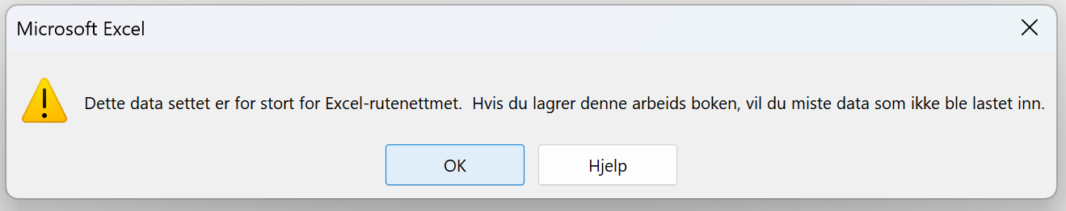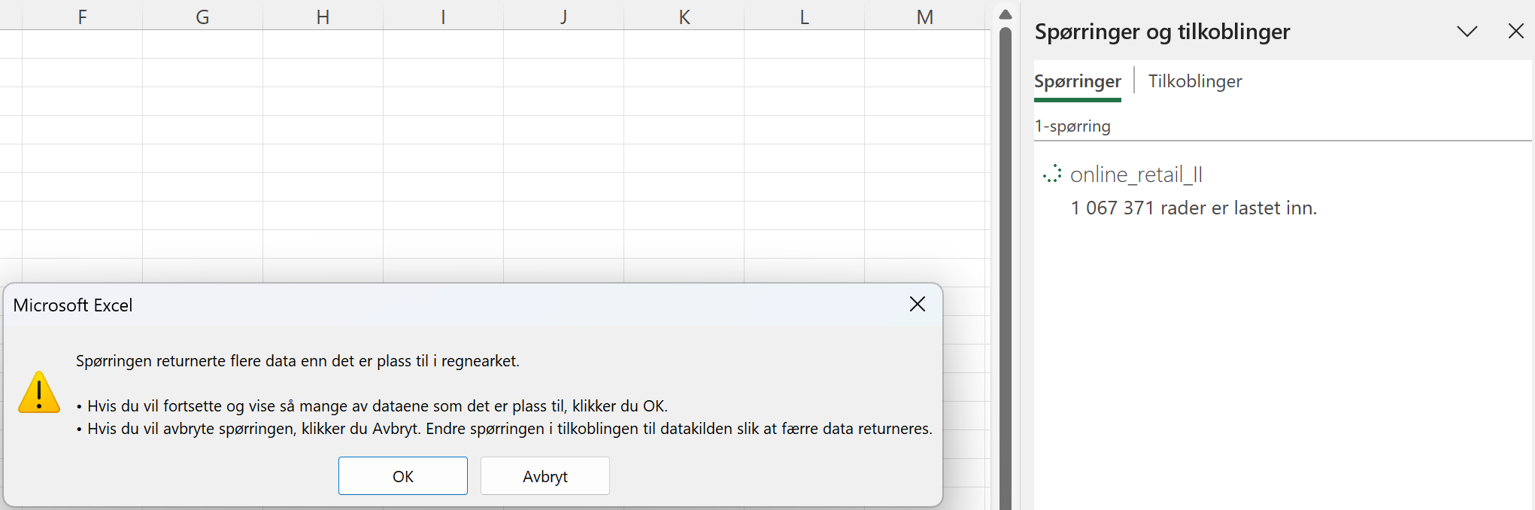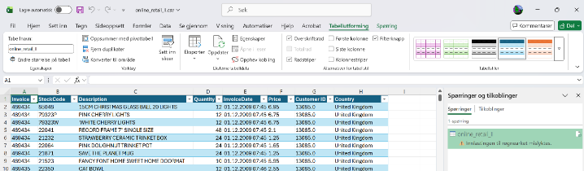But still showing us a lot of data.
Screenshot 1 from Excel showing raw data structure:
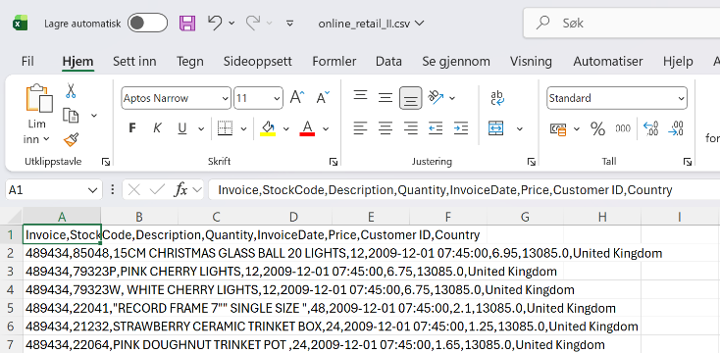

Screenshot from ETL.py showing succesful file read and row count from source file:
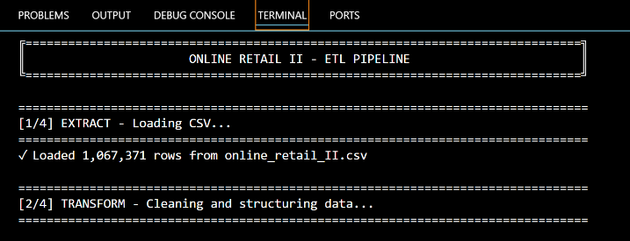

Transform data
The transform phase applies several data quality rules and business logic transformations:
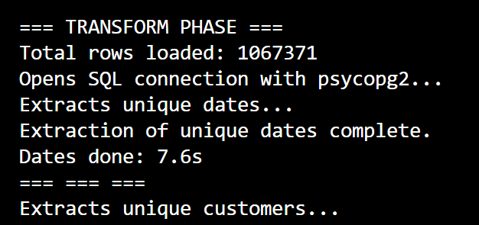
Key transformations applied:
Date conversion: InvoiceDate converted to datetime format
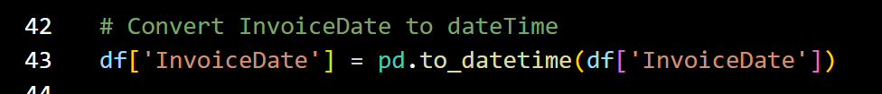
Anonymous customers: NULL CustomerID values mapped to 0
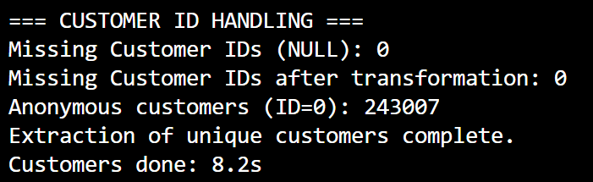
Data quality filtering: Rows with Quantity = 0 excluded (meaningless transactions)
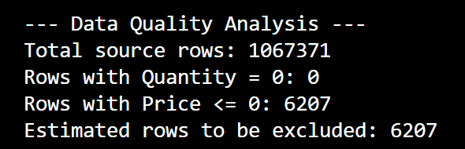
Rows with Price ≤ 0 excluded (data quality issues)
Products without descriptions excluded
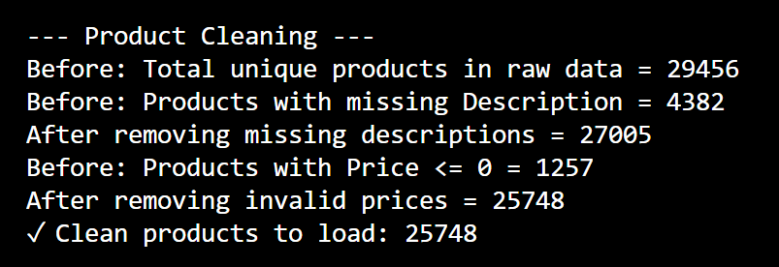

Product descriptions: Cleaned with trim and title case formatting
Business logic: Separated sales (positive quantity) from cancellations (negative quantity)
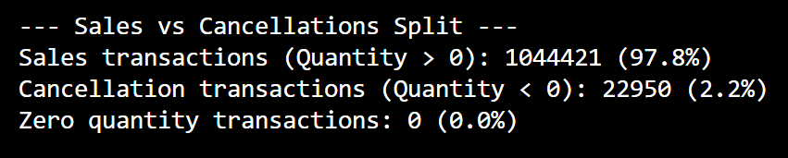

Load
The load phase populates dimension tables first (to establish foreign keys), then loads fact tables:
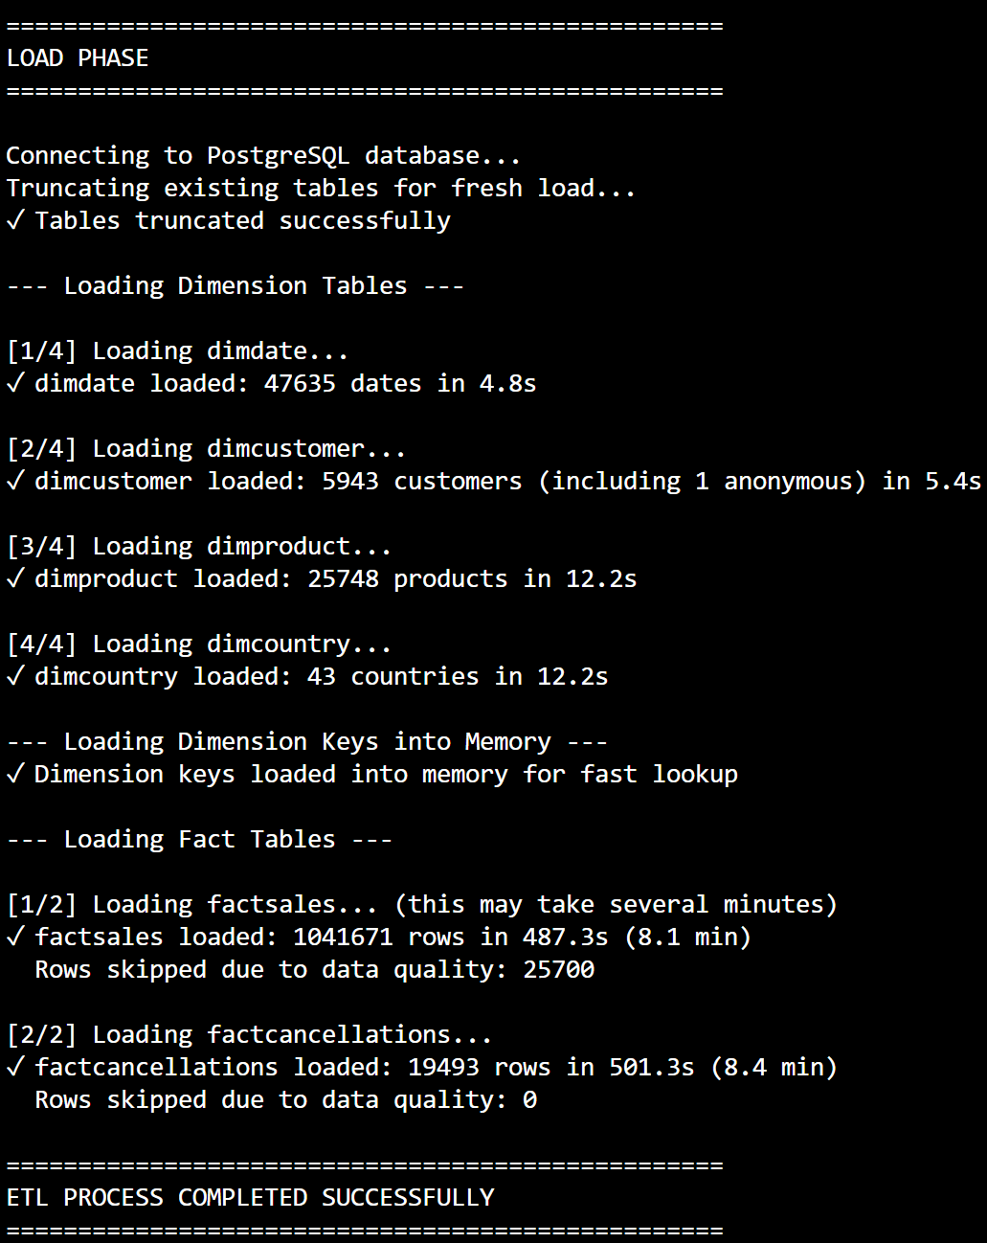
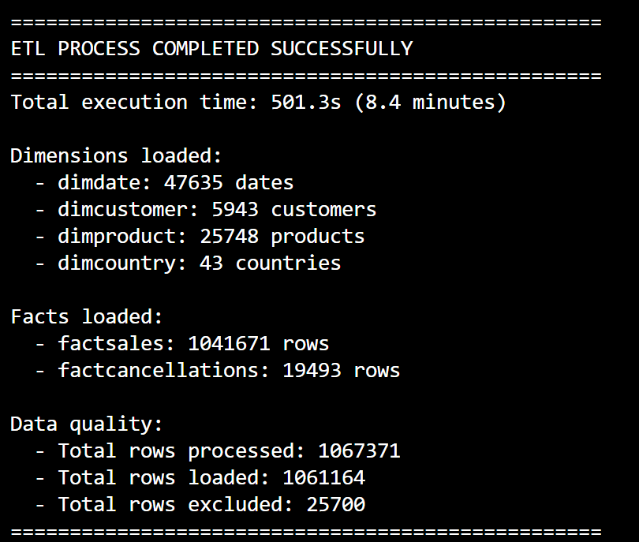

Screenshot showing 6 tables in PostgreSQL:
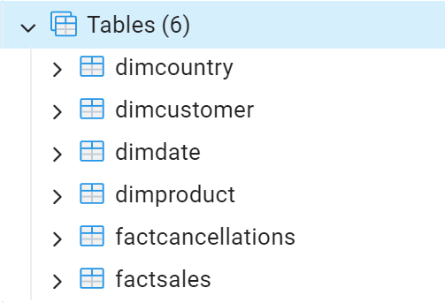
Screenshot showing data loaded in PostgreSQL with all FK and measures (quantity, unitprice, revenue)
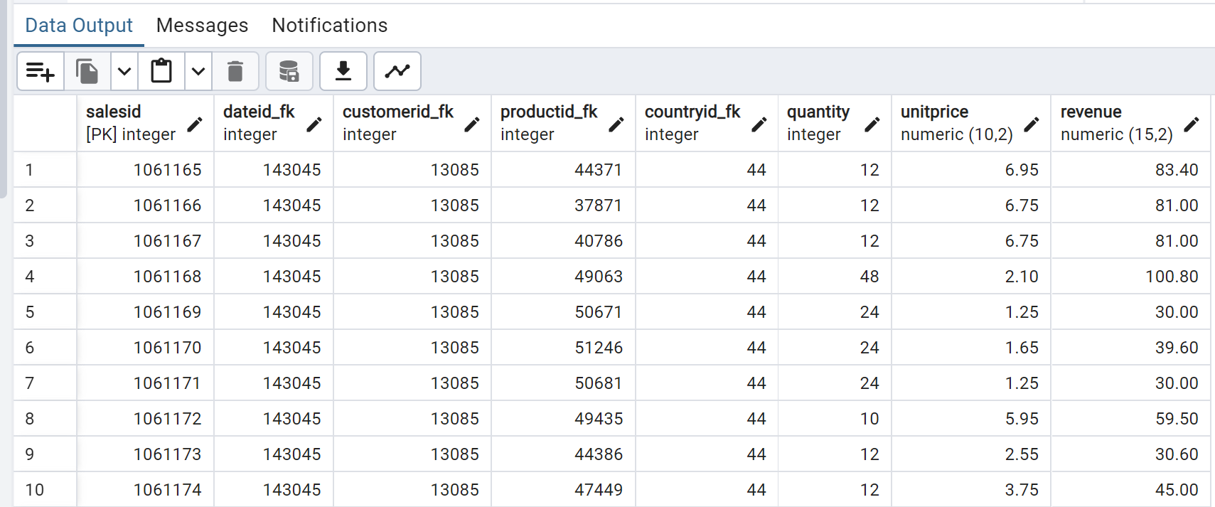
Screenshot of final populated warehouse:
